**Lecture 3**

**Hello World, Screen Orientation, Attributes/Properties**

**Scrolling for Large Text**

**1. My Application (Hello World)**

**Activity_main.xml**

*<?***xml version="1.0" encoding="utf-8"***?>*<**RelativeLayout xmlns:android="http://schemas.android.com/apk/res/android"  
 xmlns:tools="http://schemas.android.com/tools"  
 android:id="@+id/activity_main"  
 android:layout_width="match_parent"  
 android:layout_height="match_parent"  
 android:padding="20dp"  
 tools:context="com.example.mms.myapplication.MainActivity"**>  
  
 <**TextView  
 android:layout_width="wrap_content"  
 android:layout_height="wrap_content"  
 android:textSize="30sp"  
 android:textColor="#cd1222"  
 android:text="Jahangirnagar University"** />  
  
 <**TextView  
 android:layout_width="wrap_content"  
 android:layout_height="wrap_content"  
 android:textSize="50sp"  
 android:textColor="#121ecd"  
 android:text="IIT-JU"  
 android:layout_centerHorizontal="true"  
 android:layout_marginTop="200dp"  
 android:id="@+id/textView2"** />  
</**RelativeLayout**>

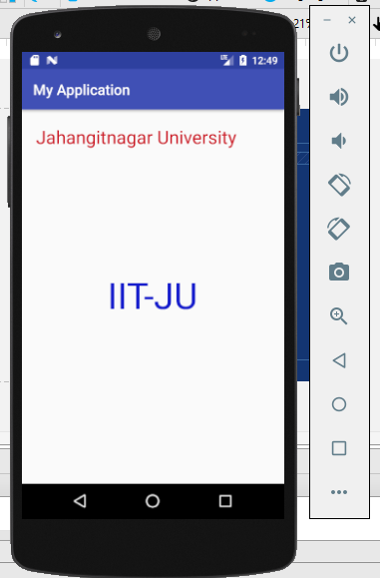

**For Large Text and Screen Orientation**

To write **large text** instead of “Hello World”

Go to

res -> values -> strings.xml

**strings.xml**

<**resources**>  
 <**string name="app_name"**>PmitFall</**string**>  
 <**string name="name_text"**>Jahangirnagar University ………… </**string**>

<**string name="name_dept"**>IIT_JU</**string**>

</**resources**>

---------------------------------------------------------------------

<**resources**>  
 <**string name="app_name"**>PmitFall</**string**>  
 <**string name="name_text"**>Android is a mobile operating system developed by Google, based on a modified version of the Linux kernel and other open source software and designed primarily for touchscreen mobile devices such as smartphones and tablets.  
 \n\n  
 In addition, Google has further developed Android TV for televisions, Android Auto for cars, and Wear OS for wrist watches, each with a specialized user interface. Variants of Android are also used on game consoles, digital cameras, PCs and other electronics.</**string**>

<**string name="age_text"**> 50 years </**string**>  
</**resources**>

**activity_main.xml**

*<?***xml version="1.0" encoding="utf-8"***?>*<**LinearLayout xmlns:android="http://schemas.android.com/apk/res/android"  
 xmlns:tools="http://schemas.android.com/tools"  
 android:id="@+id/activity_main"  
 android:layout_width="match_parent"  
 android:layout_height="match_parent"  
 android:padding="20dp"  
 android:gravity="center"  
 android:orientation="vertical"  
  
 tools:context="com.example.mms.pmitfall.MainActivity"**>  
  
 <**ScrollView  
 android:layout_width="wrap_content"  
 android:layout_height="wrap_content"**>  
  
 <**TextView  
 android:layout_width="wrap_content"  
 android:layout_height="wrap_content"  
 android:textSize="30dp"  
  
 android:text="@string/name_text"  
 android:textAllCaps="false"  
 android:textIsSelectable="true"  
 android:textColorHighlight="@color/colorAccent"** />  
 </**ScrollView**>  
</**LinearLayout**>

**For Screen Orientation**

**AndroidMenifest.xml**

*<?***xml version="1.0" encoding="utf-8"***?>*<**manifest xmlns:android="http://schemas.android.com/apk/res/android"  
 package="com.example.mms.pmitfall"**>  
  
 <**application  
 android:allowBackup="true"  
 android:icon="@mipmap/ic_launcher"  
 android:label="@string/app_name"  
 android:supportsRtl="true"  
 android:theme="@style/AppTheme"**>  
 <**activity android:name=".MainActivity"**>

<**activity android:name=".MainActivity"  
 android:screenOrientation="landscape"**>

<**intent-filter**>  
 <**action android:name="android.intent.action.MAIN"** />  
  
 <**category android:name="android.intent.category.LAUNCHER"** />  
 </**intent-filter**>  
 </**activity**>  
 </**application**>  
  
</**manifest**>

